

**Setup document**

**Organizing the “Kuierpad WinterFest” event**

Course: ProP

Group: 6 - “TechQuest”

**Team**:

Kien Duc Do - 3623941

Andreea Dumitru - 3479943

Atanas Draganov - 3508277

Abdullah Alkhalaf- 3579506

**Table of content**

|  |
| --- |
| 1. Preface 2. Agreements – made with the client 3. Processes   Use-cases:  3.1 Buying tickets  3.2 Sign in  3.3 Write a review  3.4 Deposit money  3.5 Purchasing items using the QR code  3.6 Renting items  3.7 Camping spot reservation   1. Functional requirements   4.1 Website  4.2 Application   1. GUI – to do 2. Website & wireframe 3. ERD |

**1)Preface**

The document contains details of the agreements between the client Mr Frank de Lepper and the team of TechQuest for the creation of the software for the event WinterFest.

In this setup document we will talk through the deliverables as described in the project plan. We will describe the processes, functionalities and user interfaces for every application TechQuest will build.

**2)Agreements – made with the client**

We agreed to deliver the following software for the event organised by our client Mr Frank de Lepper.

**Applications:**

- An application to be used at the entrance/exit of the event;

- An application to be used at the entrance/exit of the campsite;

- An application to be used at the shops;

- An application to be used at the loaning stands;

- An application for the organization to inspect the status of the event (dashboard);

- An application to be used for the ATM.

**Others:**

- A website;

- A database;

- A presentation about the project;

**Extra features that can be added:**

- Newsletter;

- A refund option at the shops/loaning stands;

- Keep track how much of each item has been sold;

- Show the most sold items in the overview app;

- Employees login with bracelets and automatically opens the GUI of their workplace;

- The option for choosing to sleep in the same camping spot with others.

**3)Processes**

**Preconditions:**

The following preconditions are valid for every use-case mentioned under:

1. The application is running.
2. The user is logged in with their unique username and password.

If there is a precondition unique for an application, it will be mentioned in the specific use-case.

**Exceptions:**

The following exceptions are valid every use-case mentioned under:

1. Connection lost.

**3.1 Buying tickets**

1. The website is accessed;
2. Customer presses the “Tickets” button;
3. The number of tickets is being chosen & number of persons for the camping spot as well;
4. Press “Next” button and go to the step 2 of purchasing the ticket;
5. Fill in with the personal information of the person/s and press “Next”;
6. Now the customer is redirected to the payment page ;
7. [OPTIONAL] The ticket is being downloaded.
8. [OPTIONAL] The customer redirected to the login page.
9. ///!!!!==IMPROVE THE TEST CASES==!!!/////--add info related to the system

**3.2 Sign In**

* + 1. Press the “Sign In” button;
    2. Fill in the username;
    3. Fill in the password;
    4. The user is welcomed and details about his/her account are being shown.

**3.3 Write a review**

* + 1. Access the website;
    2. Click on the “Reviews” button;
    3. If having an account, he/she can review the event. If the person doesn’t have an account, giving a review is possible only after purchasing a ticket.

**3.4 Deposit money**

* + 1. Purchase ticket
    2. Sign in to the personal account
    3. Press the “Deposit” button after filling with the desired amount.

**3.5 Purchasing items using the QR code**

* + 1. Go to the shop;
    2. Choose an item/items;
    3. Open the app [or hand in the QR code];
    4. The employee scans the QR code.
    5. Employee: confirm the purchase.

**3.6 Renting items**

Same procedure as in the case of purchasing items 3.5.

**3.7 Camping spot reservation**

The camping spot reservation is being processed when purchasing the ticket.

**4. Functional requirements**

**MoSCoW table**

|  |  |  |  |  |
| --- | --- | --- | --- | --- |
| Requirements | Must | Should | Could | Won’t |
| **4.1 Website** | | | | |
| Check the information about the Event | **☺** |  |  |  |
| Contact with the Organizer. |  | **☺** |  |  |
| Buy tickets and reserve camping spots. | **☺** |  |  |  |
| Refund a ticket and camping spots. |  |  | **☺** |  |
| Register an account for the website. | **☺** |  |  |  |
| Re-book the tickets and camping spots |  |  |  | **☺** |
| Log in with Facebook or Twitter |  |  |  | **☺** |
| Newsletter |  |  | **☺** |  |
| Admin section |  |  |  | **☺** |
| Add balance to the employees |  |  | **☺** |  |
| Log in with the QR code | **☺** |  |  |  |
| Requirements | Must | Should | Could | Won’t |
| **4.2 Applications** | | | | |
| Entrance/Exit festival application | **☺** |  |  |  |
| Is entry successful? |  | **☺** |  |  |
| Employee: Campsite access? | **☺** |  |  |  |
| User info transferred to QR code | **☺** |  |  |  |
| Employee: Exit festival application |  | **☺** |  |  |
| Employee: Loaned items returned? | **☺** |  |  |  |
| Employee: Food and Drinks shops application | **☺** |  |  |  |
| Employee check in |  |  | **☺** |  |
| Remove an item from the order |  | **☺** |  |  |
| Order preview |  | **☺** |  |  |
| Total cost |  | **☺** |  |  |
| Buying of items is successful? | **☺** |  |  |  |
| Decrease the balance of the user |  | **☺** |  |  |
| Loaning stands application | **☺** |  |  |  |
| Select multiple items |  |  | **☺** |  |
| Order preview |  | **☺** |  |  |
| Loaning successful? |  | **☺** |  |  |
| Employee: Return item | **☺** |  |  |  |
| Update database (delivery) | **☺** |  |  |  |

**5. GUI – to do**

**6. Website & wireframe**

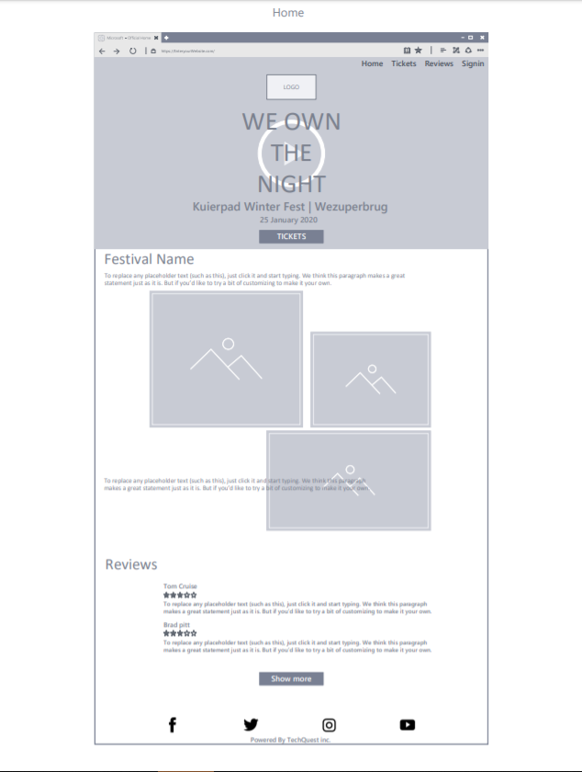

**7. ERD**